10th June 2016

**FIA WTCC Looking ahead to the Race of Russia**

The FIA World Touring Car Championship, which has YOKOHAMA as Official Tyre supplier, visits Moscow at the weekend for the exciting Race of Russia.

With the Citroen Racing driver Jose Maria Lopez enjoying a strong 69 point lead coming into the halfway mark of the Championship, second placed Tiago Monteiro from Honda, re-appears after nursing some bruises sustained following a heavy crash at the Legendary Nuerburgring - Race of Germany, a couple of weeks ago. Monteiro’s new British team mate from this season, Rob Huff, formerly with Lada is well acquainted with the Moscow track which he describes as “fantastic” and which offered him a brilliant second place last season. Spirits are high at Honda, following some very good results in the first part of the Championship and third team member Norbert Michelisz is also looking forward to plenty of overtaking opportunities that the Moscow Raceway offers, especially in the long straight heading into the final corner.

Lada, on home soil, will also want to make full use of their track knowledge and are hopeful for a podium place and valuable manufacturer Championship points.

In the independents trophy, the competition is fierce and close with Tom Chilton, in hot pursuit of Leader Mehdi Bennani.

Drivers Championship current standings:

1 LOPEZ 193

2 MONTEIRO 124

3 HUFF 122

4 MICHELISZ 120

“Independent’s Trophy”

1 BENNANI 95

2 CHILTON 78

3 CORONEL 55

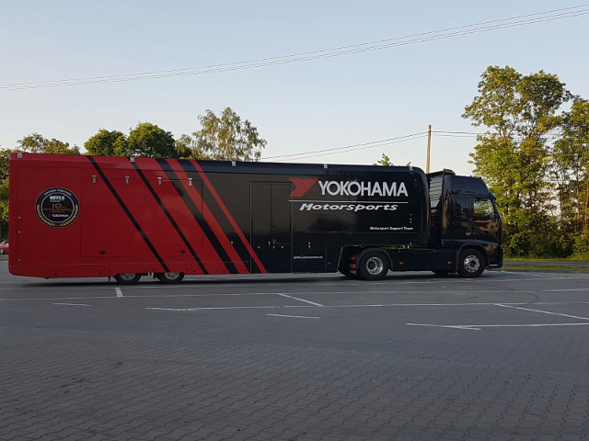

*Motorsport Support Truck brief stop in Poland en route to FIA WTCC Race-Photo Mark Stone*

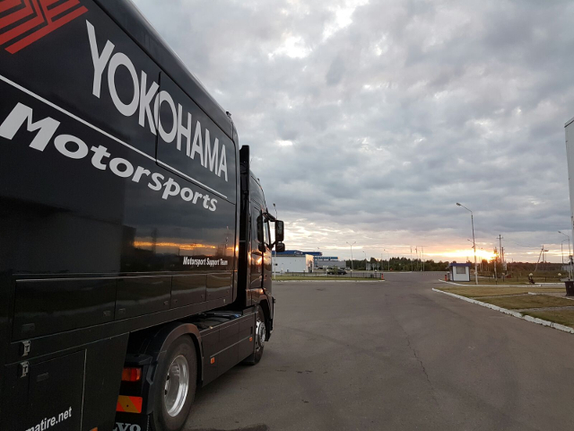

*Motorsport Support Truck en route to WTCC Race of Russia-Photo Mark Stone*

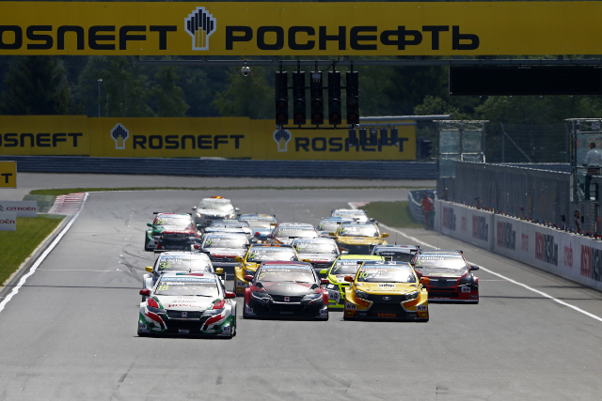

*WTCC ROSNEFT Race of Russia 2015*

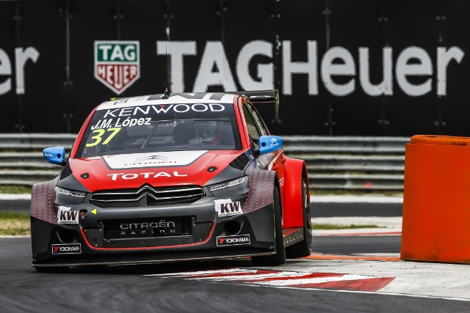

*WTCC Jose Maria Lopez*

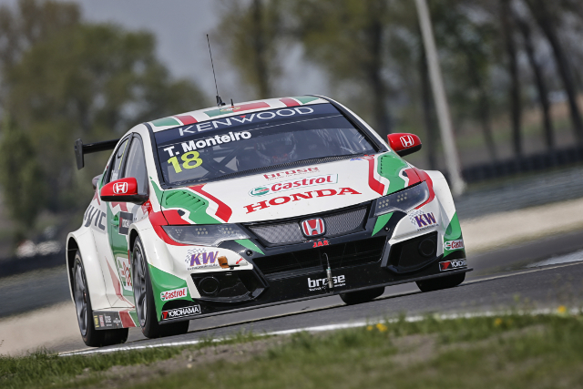

*WTCC Tiago Monteiro*